Experimental Setup Procedures for High Rate Sedimentation, Summer 2018

**Original Configuration**

Below is a schematic diagram of the setup for HRS experiments. All valves on tubing are drawn as open, and arrows are used to indicate the directions that water, clay, or coagulant may flow during various stages setup or experimentation.

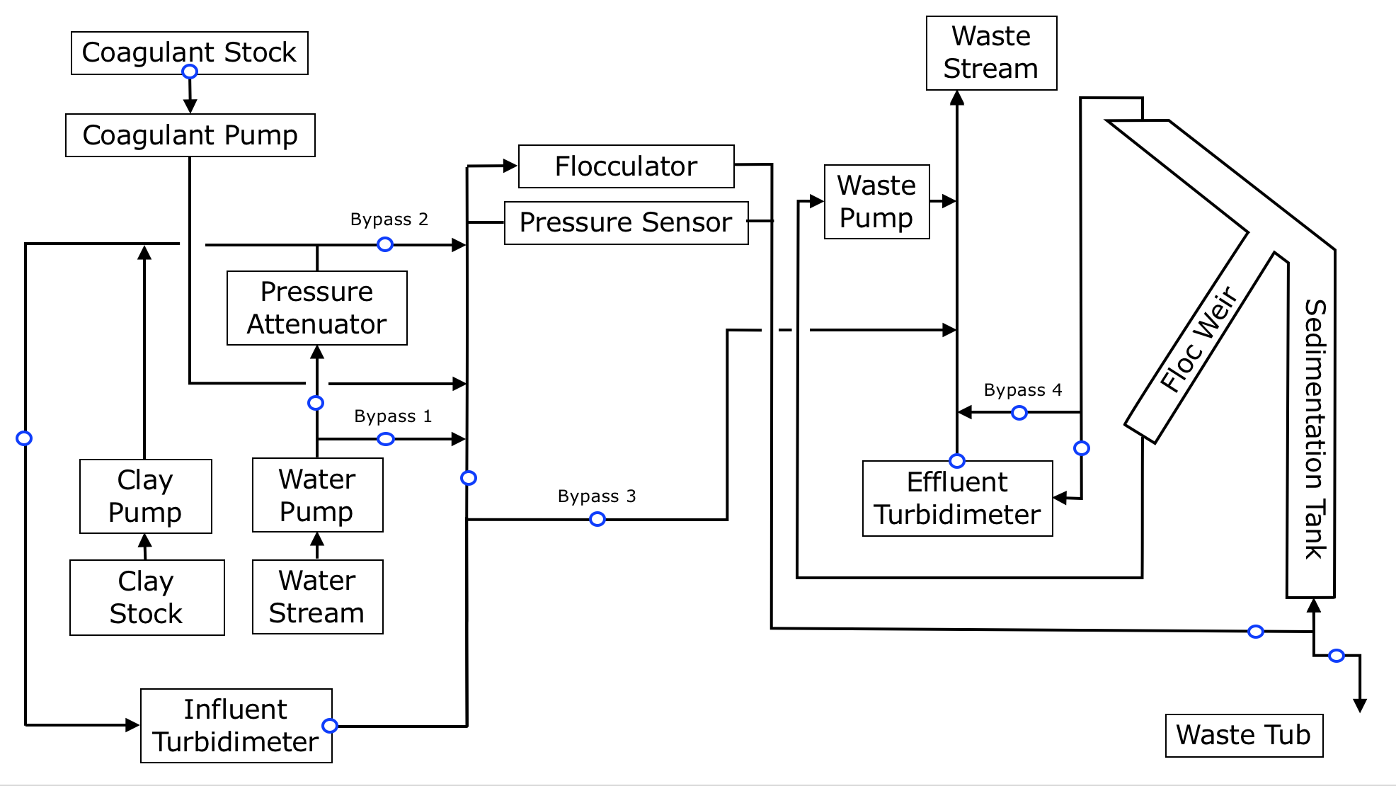



**Setup Procedures**

1. Drain the sedimentation tank.
   1. Close the valves that might allow backflow into the sedimentation tank’s effluent tube. Disconnect that tube.
   2. Close the valve between the flocculator and sed tank and the effluent turbidimeter valve to prevent backflow.
   3. Open the valve that drains the sed tank from the bottom.
   4. Disconnect the tube attached to the floc weir and catch the draining fluid in a waste bucket or tub.
   5. Reconnect the tube to the floc weir. Turn on the waste pump to drain the floc weir throughout the rest of the setup.
      1. The waste pump should be controlled by ProCoDa, so turning it on means turning on ProCoDa and then manually disabling the clay pump.

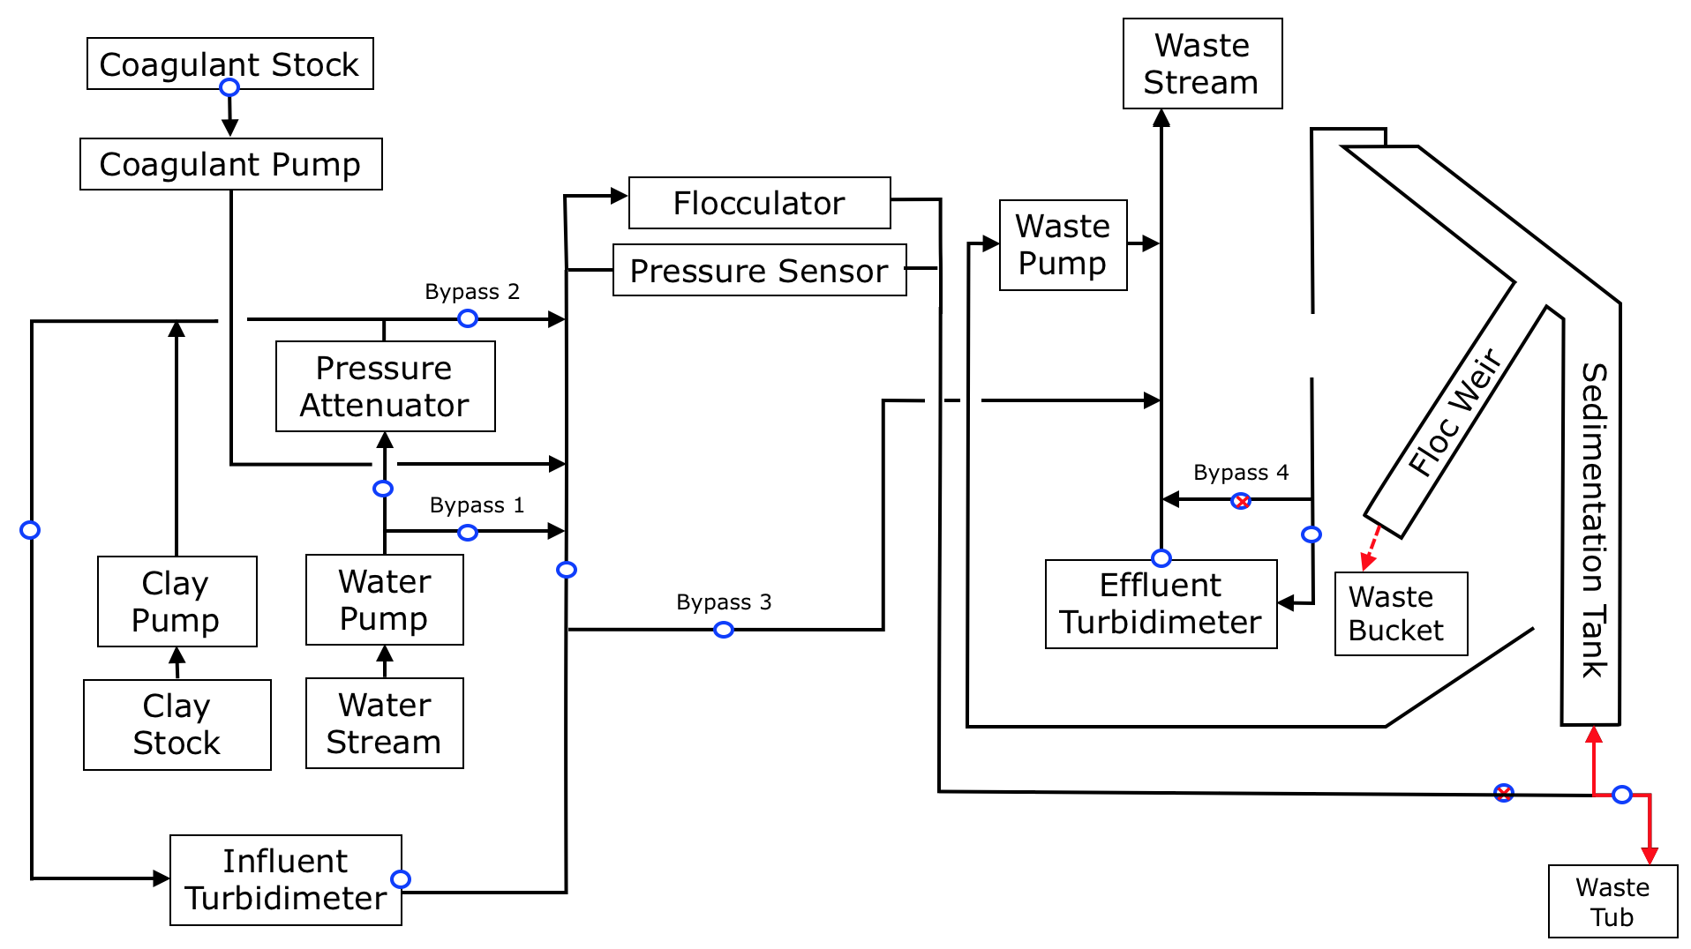

1. Clean the flocculator and sed tank
   1. Close values leading to the flocculator.
   2. Take the disconnected effluent tube (see step 1) and connect it to end of the flocculator.
   3. Connect one end of a long cleaning tube to the beginning of the flocculator.
   4. Connect the other end of the cleaning tube to the sink and turn on the faucet slowly. Make sure that the water is not rising more than a couple inches from the bottom of the sed tank. Continue for 30 seconds.
   5. Turn off the faucet and redo all connections that were changed in steps 1 and 2.

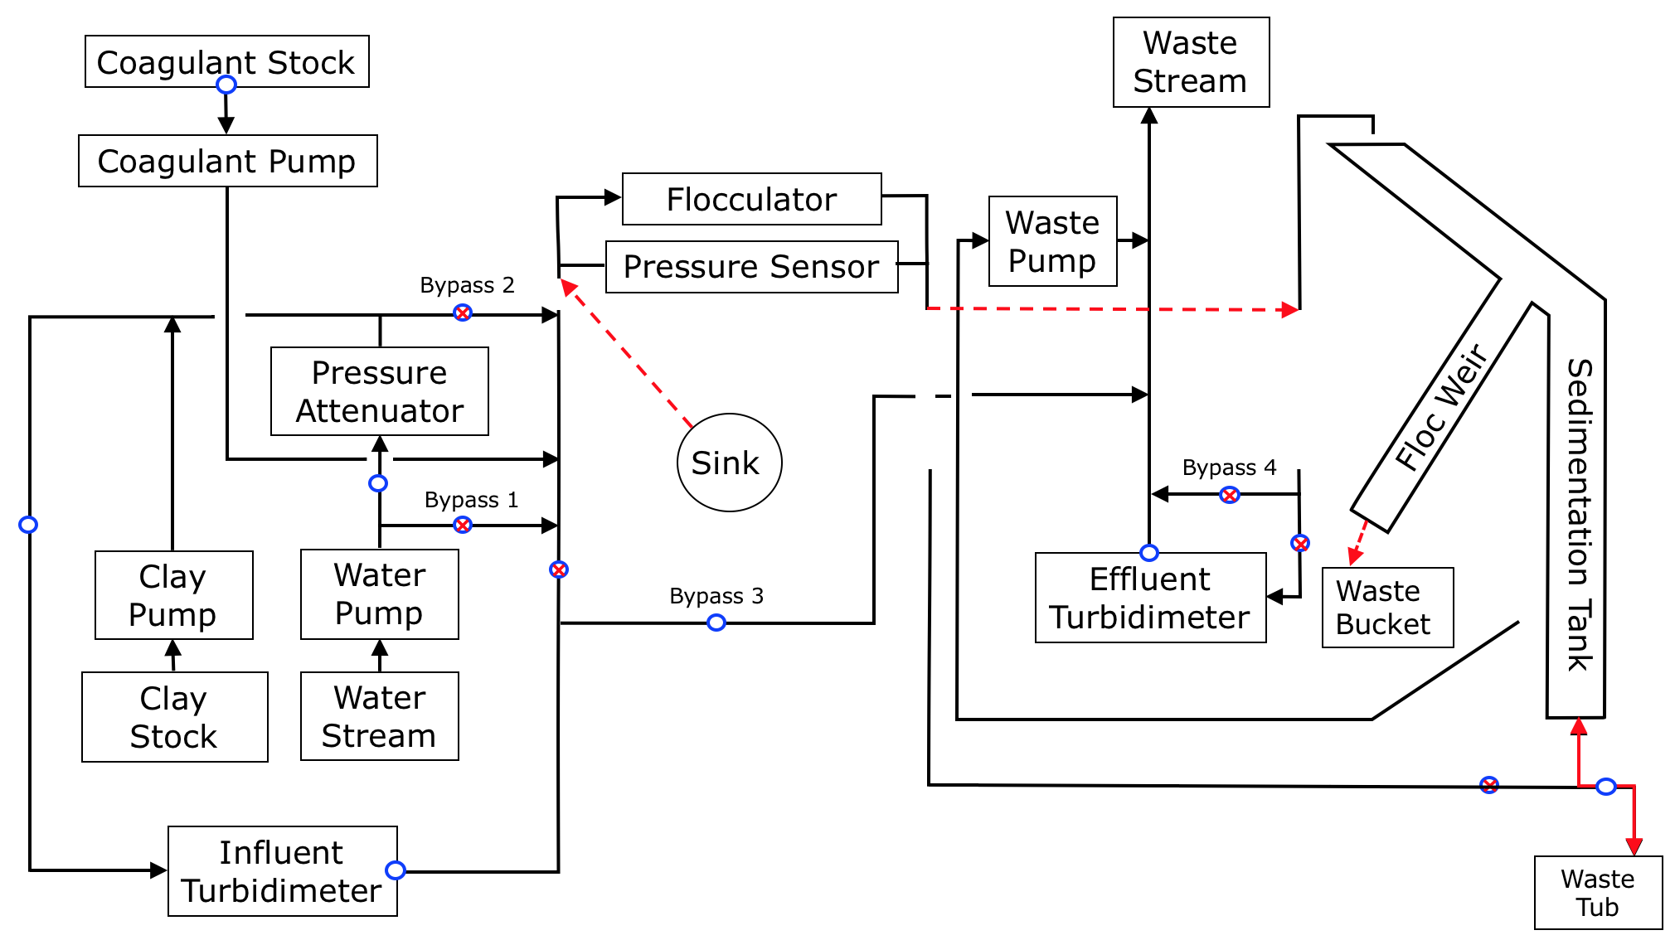

1. Clean out the pressure attenuator
   1. Close valves on either side of the pressure attenuator.
   2. If there is water inside the pressure attenuator bottle, flip it upside down (so water does not spill out) and remove the tubes connected to the inlets and outlets.
   3. Pour out the contents and rinse the bottle.
   4. Add enough water to cover the inlet and outlet holes, screw the cap on, flip the bottle upside down, and insert the tubes back into the inlets and outlets.

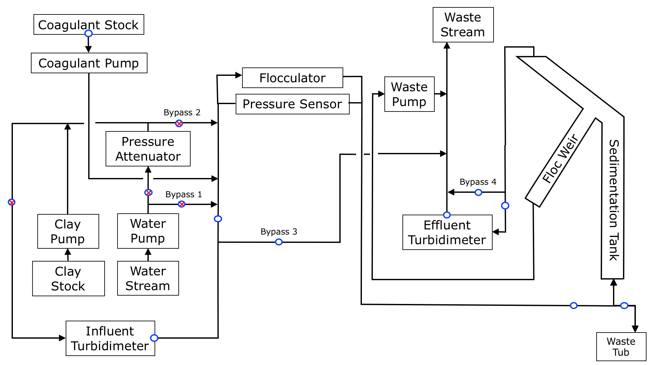

1. Disconnect coagulant pump from system and check if coagulant is pumping through correctly. Make sure the coagulant valve is open. There should be steady droplets of solution. Reconnect to the system.

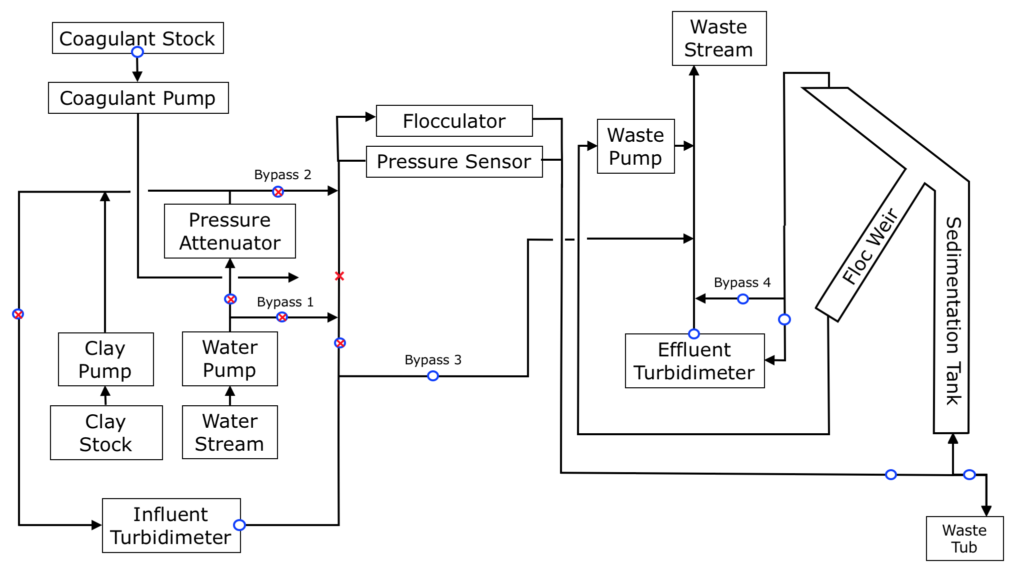

1. Run water through the system while bypassing the pressure attenuator (the pressure attenuator will become overly pressured if there is both air and water in the tubes).
   1. **While waiting for one of the longer steps of the setup to complete, start making the coagulant stock.**

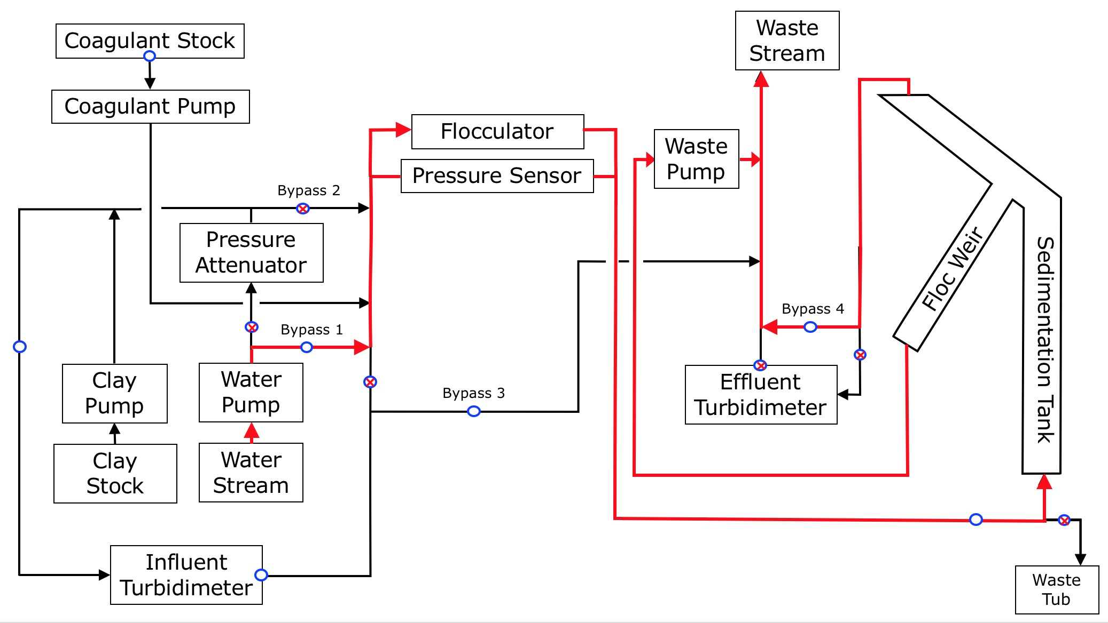

1. After the water reaches the top of the sed tank, shut off the water pump and drain the sed tank again.
   1. Repeat steps 5 and 6 to achieve a more thorough cleaning of the sed tank.

**SEE FIGURE FOR STEP 1**

1. Now run water only through the system *with the pressure attenuator* until effluent turbidity stabilizes near 0 NTU
   1. Pressure Buildup
      1. If you see the water rising steadily in the pressure attenuator (and the water level was already above the outlet), there is still pressure buildup in the system, most likely caused by a closed valve or the presence of air in the tubing.
      2. If there is still air, redirect flow to waste instead of the flocculator (after the influent turbidimeter), then direct it back through the flocculator and the rest of the system when the bubbles are removed.
   2. Rising Influent Turbidity
      1. Because bypassing the pressure attenuator (in the previous step) also involves bypassing the influent turbidimeter, the influent turbidimeter may show high (e.g. over 10 NTU) turbidity values when you begin running water through it due to remaining clay deposits in the tubing.
      2. In that case, divert the water exiting the influent turbidimeter to waste instead of the rest of the system, until the influent turbidity is reasonably low (e.g. below 2 NTU).
      3. Note: after directing the water from the influent turbidimeter back into the system, you must still stabilize effluent turbidimeter to near 0 NTU.

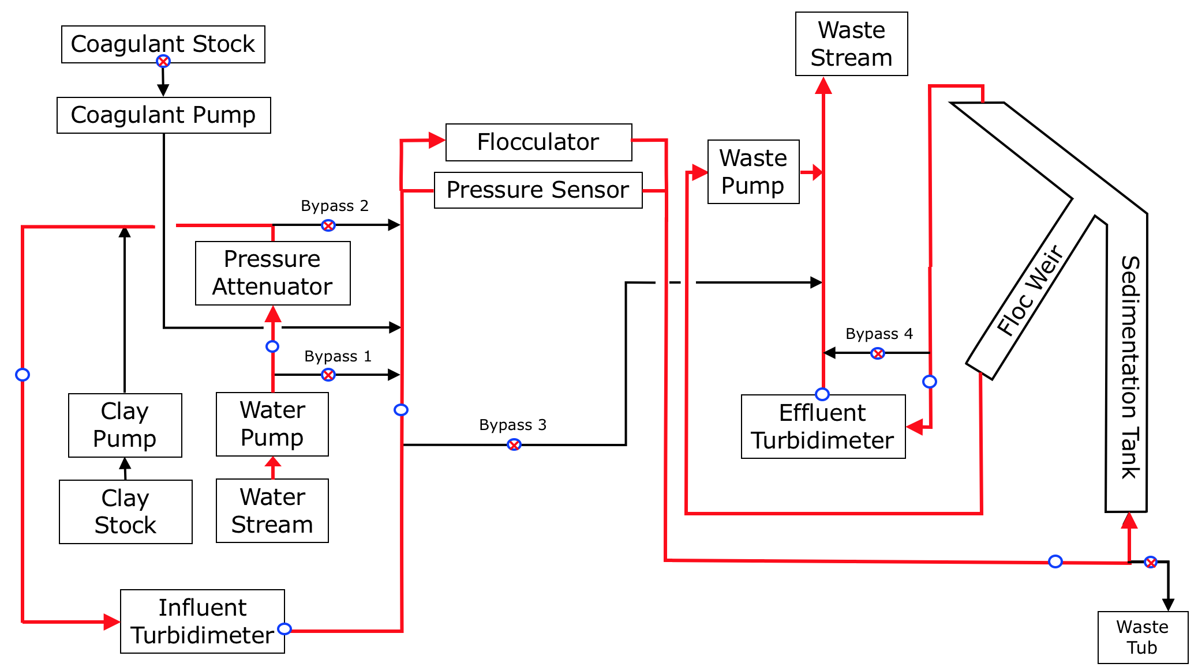

1. Clean out influent and effluent turbidimeters
   1. Even without water running, shut and open the appropriate values to bypass the turbidimeter so that water doesn't leak into it while cleaning
   2. Unlock and take out the black cylinder on top of the turbidimeter. **Loosen** the input and output tubes on top of the cylinder.
   3. Unscrew the glass vial, empty and rinse it, then fill it with clean water. Tap water is sufficient.
   4. Screw the vial back in, wipe the bottle and cylinder free from water droplets or fingerprints, and then lock the cylinder back into the turbidimeter.
   5. Remember to tighten the input and output tubes. If you used the white screws on the outflow turbidimeter tubes to block water passage, remember to **unscrew** them.

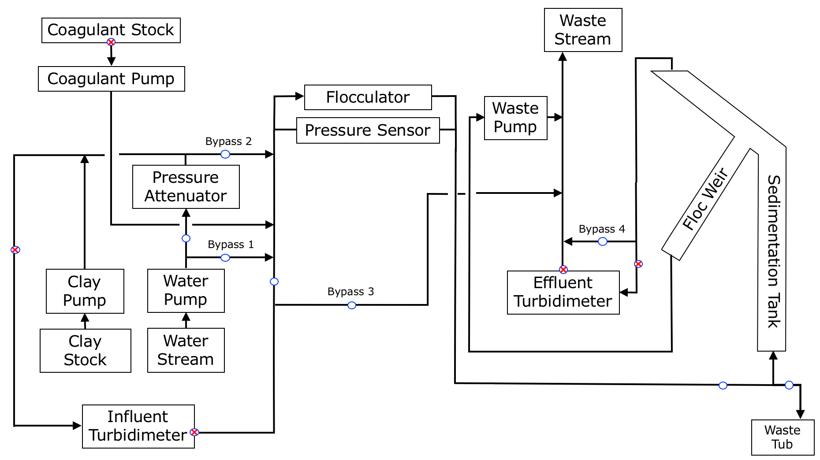

1. Redirect flow to waste instead of the flocculator.
2. Turn the clay stock stirrer and ProCoDa on.
   1. The clay pump will start running at 100 NTU. To lower it quickly to a more reasonable level, change the control mode to INT (internal), then toggle back to EXT (external) control mode.
   2. TIP: before the experiment, while the clay pump is off, set it INT mode and then use the down arrow to lower the pump speed as low as possible. This will be the speed of the pump the next time it is on and in INT control mode.
3. Stabilize influent turbidity to 100 NTU.

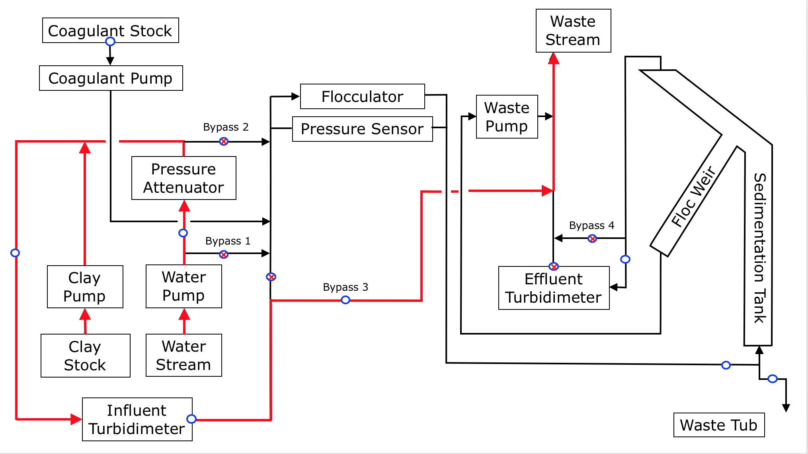

* 1. Note: For faster stabilization, make sure the clay stock is not too concentrated
     1. I.e. 2.5L of water + 30 mL of clay powder
  2. Set the “i” constant of the PID control to be 0 until the influent turbidimeter decreases down to around 115 NTU at which point you should change this “i” constant up to 2

1. Connect coagulant tubing back to main system and run experiment.

